**Spatially-spectrally resolved imaging.**

In the following an example of how to perform spatially resolved spectroscopy using our spectrometer will be shown. In the examplet below the same Andor software is used (spectrometer is integrated with Newton CCD, not EMCCD).

**Example**, Mapping quantum dot emission from ring resonators. The ring resonator integrated with quantum dots exhibit laser emission. The modes are confined at the rim of the resonator so that almost all the emission comes from this region. So how to map the emission and see from where the light comes from?

1. Try to see a clear image of your structure (it can be rough surface, even dirt) that is placed at the centre of your optical axis and make sure that the image you see in your camera (e.g., Thorlabs laser alining Camera) is perfectly aligned to be seen at the entrance slit of the spectrometer. This is quite easy (just use white paper to see it).

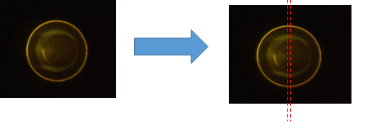

1. Take the spatially resolved image as shown below. Since the middle region of the structure is the one entering the spectrometer, only this portion will be observed. The signal from other regions (e.g., left region) cannot be observed. As expected the light from the rim of the ring resonator is imaged while the central region has no signal.

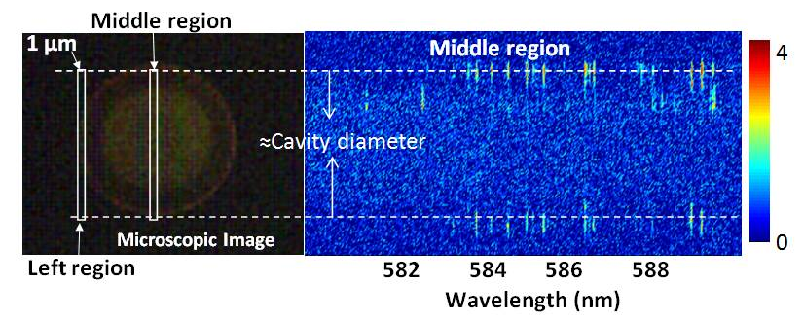

1. By moving the sample along the horizontal axis (e.g, at a step of 0.5 µm-1 m), one can image the whole ring. For each measurement a data must be saved for a final construction of the whole region. Figure below shows the imaging of this ring resonator which is marked left region in the above image.

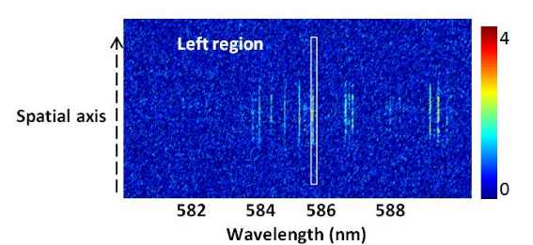

1. After scanning the whole region, the image can be reconstructed to see the whole ring. Figure below shows few of our results. As shown in Figure belw for every required wavelength you automatically correlate the image. For example, in our case Raman images, silicon vacancy, Nitrogen vacancy can be imaged in one shot. Figure below shows one resonator image but the emission wavelength is different.

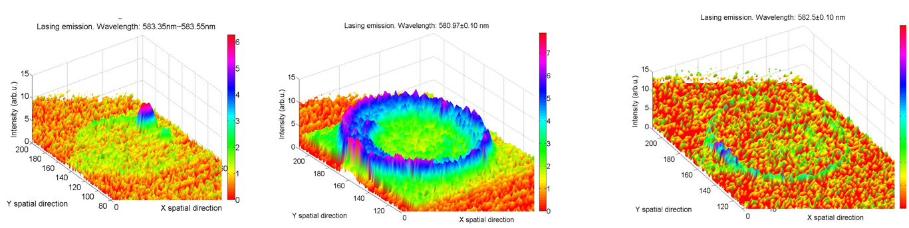

1. .ASC, .SIF, JPEJ, TIFF files can be easily obtained from Andor. For the construction of the 2D and 3D images I have a matlab code which you can use to start your measurement. You can modify in the best way to match your need.